90

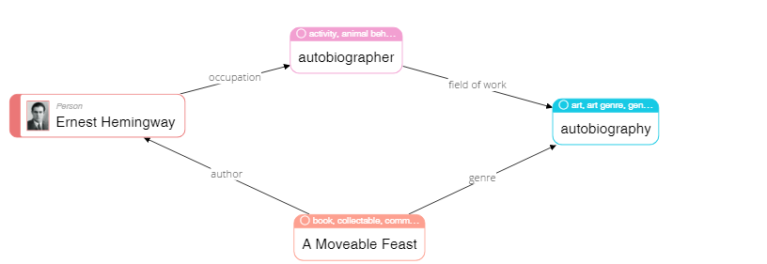

|  |
| --- |
| **Please describe shortly what you see on this diagram? Pay attention only to that information that is understandable or has sense for you.** |
| Autobiographer Ernest Hemingway is an author of A Moveable Feast |

68

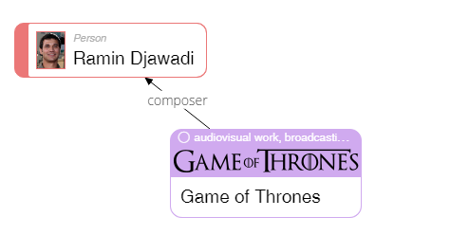

|  |
| --- |
| **Please describe shortly what you see on this diagram? Pay attention only to that information that is understandable or has sense for you.** |
| Ramin Djawadi is a composer of the Game of Thrones |

23

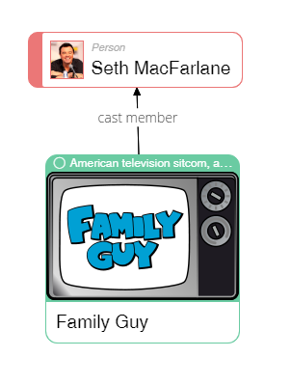

|  |
| --- |
| **Please describe shortly what you see on this diagram? Pay attention only to that information that is understandable or has sense for you.** |
| Seth MacFarlane is a cast member of the Family Guy sitcom. |

50

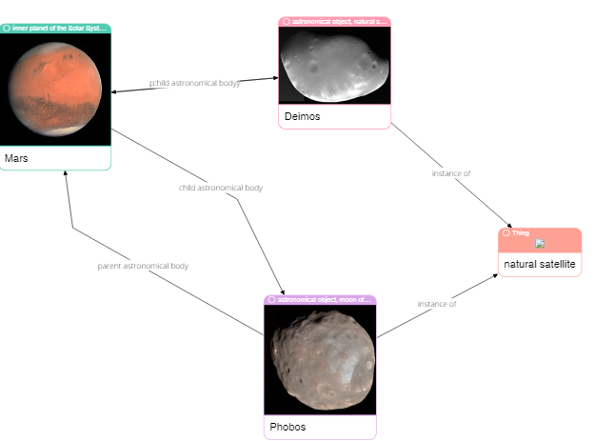

|  |
| --- |
| **Please describe shortly what you see on this diagram? Pay attention only to that information that is understandable or has sense for you.** |
| The Deimos and Phobos are a satellites of the Mars, but Deimos is also a Mars’s astronomical parent. |

62

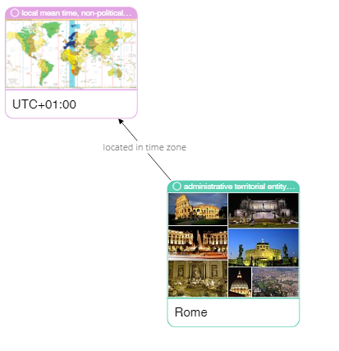

|  |
| --- |
| **Please describe shortly what you see on this diagram? Pay attention only to that information that is understandable or has sense for you.** |
| Rome’s time zone is UTC+01:00 |

75

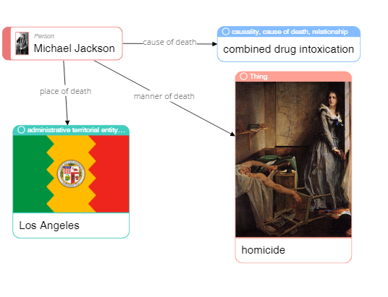

|  |
| --- |
| **Please describe shortly what you see on this diagram? Pay attention only to that information that is understandable or has sense for you.** |
| Michael Jackson was killed in Los Angeles by combined drug intoxication |

79

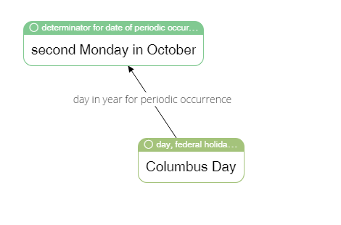

|  |
| --- |
| **Please describe shortly what you see on this diagram? Pay attention only to that information that is understandable or has sense for you.** |
| Columbus Day is the second Monday in October |

65



|  |
| --- |
| **Please describe shortly what you see on this diagram? Pay attention only to that information that is understandable or has sense for you.** |
| Ole Kirk Christiansen that worked as an entrepreneur, carpenter and joiner, has invented Lego |

4

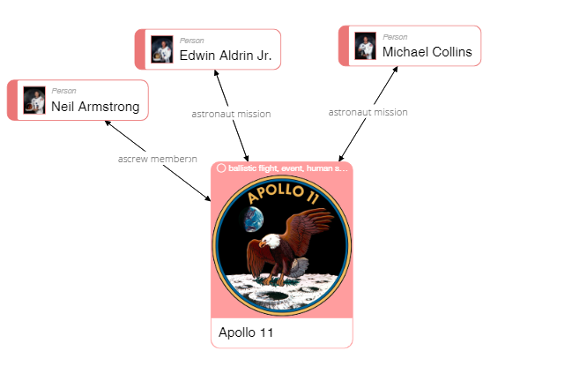

|  |
| --- |
| **Please describe shortly what you see on this diagram? Pay attention only to that information that is understandable or has sense for you.** |
| Neil Armstrong is an “ascrew memberon” of Apollo 11. Edwin Aldrin Jr., Michael Collins and Apollo 11 are each other’s astronaut mission |

40

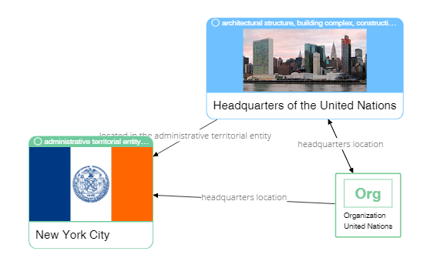

|  |
| --- |
| **Please describe shortly what you see on this diagram? Pay attention only to that information that is understandable or has sense for you.** |
| Headquarters of the United Nations, that is a headquarters of the United Nations organization is located in the administrative territorial entity of New York City |

37



|  |
| --- |
| **Please describe shortly what you see on this diagram? Pay attention only to that information that is understandable or has sense for you.** |
| F.C. Porto, which headquarters is located in Porto, is somehow connected to the stadium Estadio do Dragao |